
W1-2-60-1-6
JOMO KENYATTA UNIVERSITY
OF
AGRICULTURE AND TECHNOLOGY
University Examinations 2012/2013
THIRD YEAR FIRST SEMESTER EXAMINATION FOR THE DEGREE OF BACHELOR OF SCIENCE IN MATHEMATICS AND COMPUTER SCIENCE
SMA 2304: ORDINARY DIFFERENTIAL EQUATIONS I
DATE: APRIL 2013 TIME: 2 HOURS
INSTRUCTIONS: Answer Question ONE and any other TWO Question

Question One

a) Obtain the differential equation associated with the equation (x – A)² + (y – B)² = 1, where A and B are arbitrary constants. (5 Marks)

b) By separating the variables, solve the equation 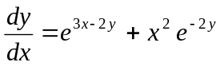 (4 Marks)

c) Solve the differential equation 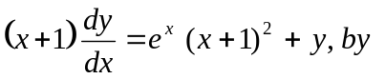finding an integrating factor. (5 Marks)

d) Find the general solution of the homogeneous solution of the homogeneous equation 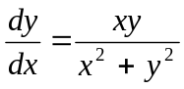 (6 Marks)

e) Uranium disintegrates at a rate proportional to the amount present at any instant. If m₁ and m₂ grams of Uranium are present at times t₁ and t₂ respectively, show that the half-life of uranium is 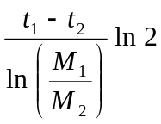 (4 Marks)

f) Solve the differential equation 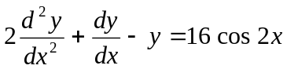 (6 Marks)
Question Two (20 Marks)

a) Check for homogeneity and hence or otherwise solve the equation 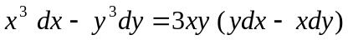 (10 Marks)

b) Find the general solution of the Bernoulli equation 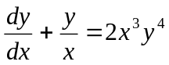 (10 Marks)

Question Three (20 Marks)

a) By making an appropriate substitution, solve the non-homogeneous equation 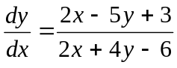 (12 Marks)

b) Solve the following system of equations 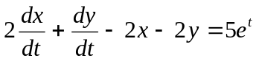 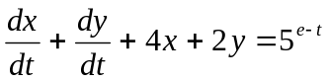, given x (0) = 2 and y (0) = 0 (8 Marks)

Question Four (20 Marks)

a) Using the method of variation of parameters, solve the equation: 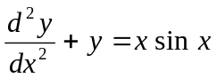 (12 Marks)

b) Find a power series solution of the equation 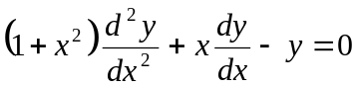 about the ordinary point x = 0 (8 Marks)

